Title | Data Manipulation and Analysis using the Starwars Dataset in R
Problem Statement | An AI company maintains model performance records containing:  •ModelID  • Accuracy  • Algorithm  Perform:  1. Select ModelID and Accuracy.  2. Filter models with Accuracy greater than 90%.  3. Add Status with default value "Production Ready".  4. Sort models by Accuracy.  5. Calculate average model accuracy.
Objectives | - Understand how AI model performance data is stored and represented in a Pandas DataFrame.  - Filter machine learning models based on conditions, such as accuracy greater than 90%.  - Learn how to select specific columns such as ModelID and Accuracy.  - Sort AI models according to their accuracy values.  - Calculate statistical values such as average, minimum, and maximum model accuracy.  - Rank machine learning models based on their performance.
Dataset  URL Link /  File | ModelID Algorithm PreviousAccuracy Accuracy  M101 Logistic Regression 84.5 87.2  M102 Decision Tree 87.0 89.5  M103 Random Forest 90.2 93.8  M104 Support Vector Machine 88.5 91.4  M105 K-Nearest Neighbors 82.5 85.6  M106 Random Forest 91.0 94.5  M107 Decision Tree 85.5 88.3  M108 Neural Network 92.0 96.1  M109 Logistic Regression 86.0 90.8  M110 Neural Network 93.1 95.4  M111 Gradient Boosting 89.4 92.7  M112 Gradient Boosting 91.8 94.1
Functions  Details | Sl. No. |  | Function |  | Package |  | Description of function
 | 1 | pd.DataFrame() |  | Pandas |  | Creates a DataFrame from the AI model data dictionary.
 | 2 | pd.read_csv() |  | Pandas |  | Reads AI model records from a CSV file.
 | 3 | dropna() |  | Pandas |  | Removes rows containing missing or invalid values
 | 4 | drop_duplicates() |  | Pandas |  | Removes duplicate records based on ModelID.
 | 5 | sort_values() |  | Pandas |  | Sorts the models according to their accuracy values.
 | 6 | mean() |  | Pandas |  | Calculates the average accuracy of all AI models.
 | 7 | groupby() and agg() |  | Pandas |  | Groups models by algorithm and calculates performance statistics.
 | 8 | to_csv() |  | Pandas |  | Saves the analysed model results into a CSV file.
Steps/  Process/  Procedure/  Algorithm/  Flowchart/  Model | - Import the Pandas package.  - Create the AI model dataset containing ModelID, Algorithm, PreviousAccuracy and Accuracy.  - Convert the dataset into a Pandas DataFrame.  - Clean the dataset by removing missing values, duplicate ModelIDs and invalid accuracy values.  - Select only the ModelID and Accuracy columns.  - Filter the models whose Accuracy is greater than 90%.  - Add a Status column with the default value “Production Ready”.  - Change the status to “Needs Improvement” for models having Accuracy below 90%.  - Sort the models in descending order based on Accuracy.  - Assign ranks to the models, where the highest-accuracy model receives Rank 1.  - Calculate the improvement of each model using:  Improvement = Accuracy − PreviousAccuracy  - Calculate the average accuracy of all models.  - Group the models by Algorithm and calculate minimum, maximum and average accuracy.  - Identify the best-performing, lowest-performing and most-improved models.  - Display all the analysis results in the console.  - Generate an automated model evaluation report.  - Save the analysed results in a CSV file and the report in a text file.
Program | import sys  from pathlib import Path  import pandas as pd  from analysis_core import (  analyse_models,  clean_data,  create_algorithm_summary,  create_report,  create_sample_data,  perform_basic_operations  )  # ============================================================  # HEADING FUNCTION  # This keeps console output neat and readable.  # ============================================================  def print_heading(title):  print("\n" + "=" * 72)  print(title)  print("=" * 72)  # ============================================================  # MAIN CONSOLE PROGRAM  #  # Run with sample data:  # python console_app.py  #  # Run with CSV data:  # python console_app.py sample_ai_models.csv  # ============================================================  def main():  print_heading("AI MODEL PERFORMANCE ANALYSIS - CONSOLE MODE")  csv_file = None  # If the user gives a file path, use that CSV.  if len(sys.argv) > 1:  csv_file = sys.argv[1]  if csv_file:  csv_path = Path(csv_file)  if not csv_path.exists():  print(f"Error: File not found: {csv_path}")  return  print(f"Using CSV file: {csv_path}")  raw_data = pd.read_csv(csv_path)  else:  print("Using built-in sample data.")  raw_data = create_sample_data()  try:  cleaned_data = clean_data(raw_data)  except ValueError as error:  print(f"Data error: {error}")  return  analysed_data = analyse_models(  cleaned_data,  production_threshold=90.0  )  results = perform_basic_operations(  analysed_data  )  print_heading("ORIGINAL CLEANED DATA")  print(  cleaned_data.to_string(index=False)  )  print_heading("1. SELECT MODELID AND ACCURACY")  print(  results["selected_columns"]  .to_string(index=False)  )  print_heading(  "2. FILTER MODELS WITH ACCURACY GREATER THAN 90%"  )  print(  results["models_above_90"][  ["ModelID", "Algorithm", "Accuracy"]  ].to_string(index=False)  )  print_heading(  '3. ADD STATUS WITH DEFAULT "PRODUCTION READY"'  )  print(  results["status_table"]  .to_string(index=False)  )  print_heading("4. SORT MODELS BY ACCURACY")  print(  results["sorted_models"][  ["ModelID", "Algorithm", "Accuracy"]  ].to_string(index=False)  )  print_heading("5. CALCULATE AVERAGE MODEL ACCURACY")  print(  f'Average model accuracy: '  f'{results["average_accuracy"]:.2f}%'  )  print_heading("MODEL RANKING")  print(  analysed_data[  [  "Rank",  "ModelID",  "Algorithm",  "PreviousAccuracy",  "Accuracy",  "Improvement",  "Status"  ]  ].to_string(index=False)  )  print_heading("ALGORITHM PERFORMANCE COMPARISON")  algorithm_summary = create_algorithm_summary(  analysed_data  )  print(  algorithm_summary.to_string(index=False)  )  print_heading("ACCURACY IMPROVEMENT TRACKING")  print(  analysed_data[  [  "ModelID",  "PreviousAccuracy",  "Accuracy",  "Improvement",  "ImprovementStatus"  ]  ].to_string(index=False)  )  report = create_report(  analysed_data,  production_threshold=90.0  )  print_heading("AUTOMATED EVALUATION REPORT")  print(report)  # Save analysed data.  analysed_data.to_csv(  "console_ai_model_results.csv",  index=False  )  # Save the report.  with open(  "console_ai_model_report.txt",  "w",  encoding="utf-8"  ) as report_file:  report_file.write(report)  print_heading("FILES CREATED")  print("console_ai_model_results.csv")  print("console_ai_model_report.txt")  if __name__ == "__main__":  main()
Output Snapshots  With  Explanation/  Observations | 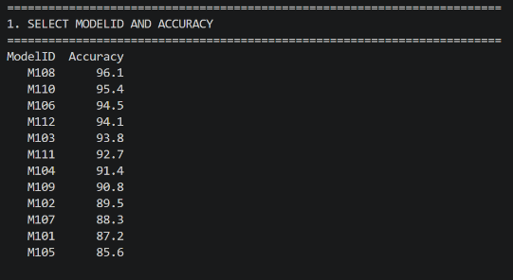  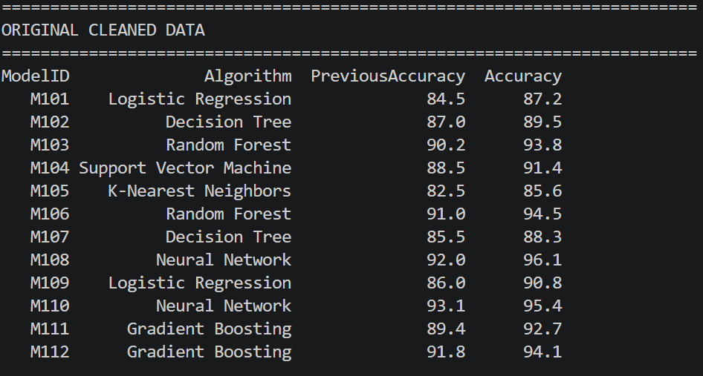  The program successfully loaded and cleaned the AI model performance dataset. The dataset contained ModelID, Algorithm, PreviousAccuracy and Accuracy.  Figure 1.2 Selected ModelID and Accuracy  Figure 2.1 Original Cleaned Dataset  The ModelID and Accuracy columns were selected successfully. Models having accuracy greater than 90% were filtered from the dataset.  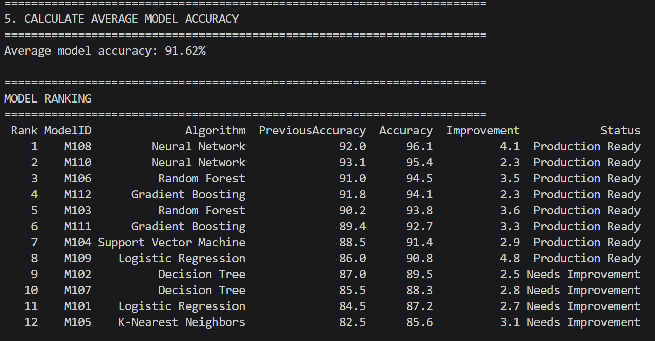  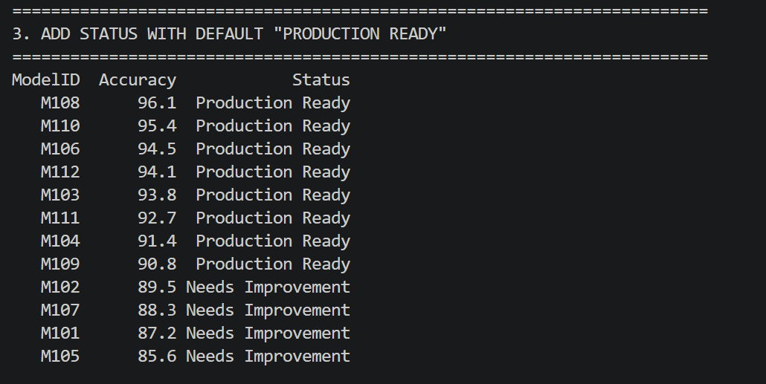  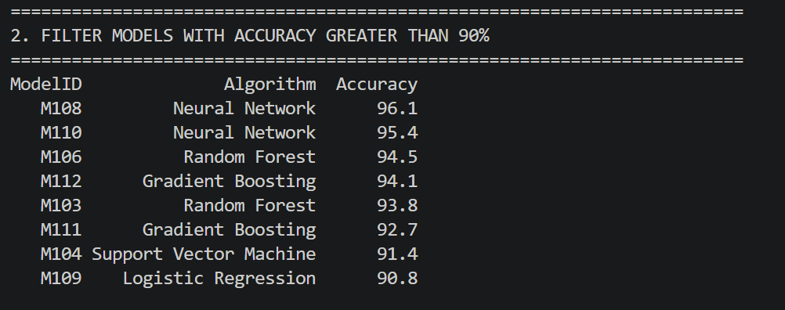  A Status column was added. Models with accuracy greater than or equal to 90% were marked as “Production Ready”, while the remaining models were marked as “Needs Improvement”.  The average accuracy of all models was calculated. Accuracy improvement was also calculated by subtracting PreviousAccuracy from the current Accuracy.  Figure 1.5 Average Model Accuracy  Figure 1.4 Status Column and Models sorted by accuracy  Figure 1.3 Models Accuracy Greater than 90%  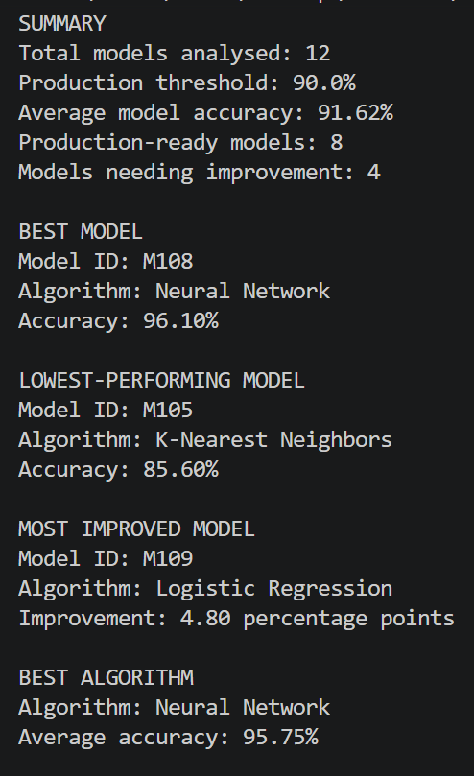  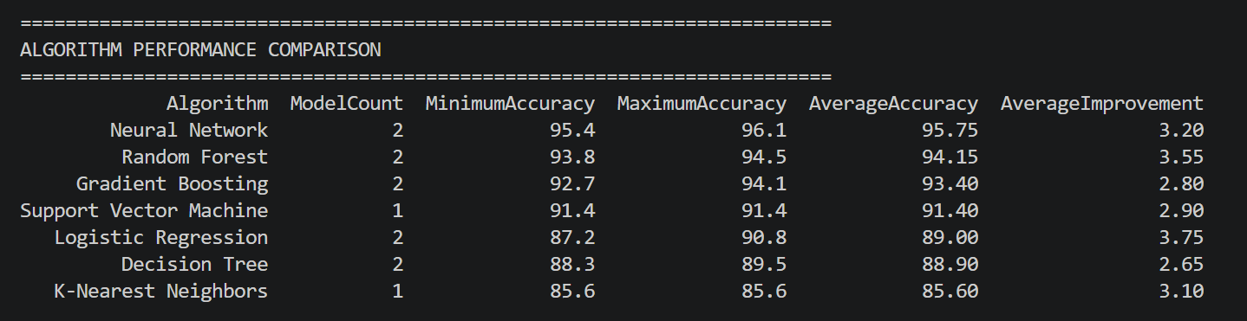  The models were grouped according to their algorithms, and minimum, maximum and average accuracy values were calculated for each algorithm.  Figure 1.6 Models Grouped according to their algorithm and other metrics  The program identified the best-performing model, lowest-performing model, most-improved model and best-performing algorithm.
Conclusions
References | - Michael Freeman and Joel Ross, Programming Skills for Data Science: Start Writing Code to Wrangle, Analyze, and Visualize Data with R, Addison-Wesley, 2018  - Python Program (Google Colab link /Githab link)  - Class lecture link

